Session Title

PAPER TITLE

Author full name¹, Author full name ²
¹Home university/organization title, City, Country
²Home university/organization title, City, Country
Speaker’s email

Authors are expected to submit their abstracts as DOC files. An abstract, including pictures, should not exceed two A5 pages. The text should be free from unnecessary hyphens and spaces. Other requirement: single spacing; all margins should be 2 cm; font – Times New Roman 9, first line indent – 0.6 cm. Paper title – FONT: TIMES NEW ROMAN, 9 PT, UPPER CASE, BOLD, CENTER ALIGNMENT. The line following the title should mention the authors’ full names separated by commas, with right alignment; the speaker’s name should be mentioned first. The following lines should mention a full name of the organisation, where it is situated (city, country), and the speaker’s e-mail address.
Picture requirements: GIF, JPEG, PNG or TIFF, min. 300 dpi. References to pictures should be given in parentheses, e.g. (Fig.1). Pictures should be center aligned. Captions: font – Times New Roman 9 pt, center alignment. Pictures created with the Word tools should be grouped.
All references to other papers included in the text should be given in brackets, e.g. [1, 2]. Per GOST 7.1-2003, a list of references should be given at the end of the paper.
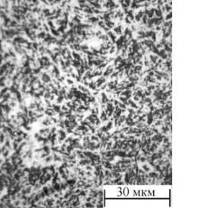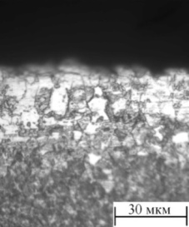
а) b)
Fig. 1. Optical photos of the specimens’ surfaces: а) not processed; b) after surface modification (section)

References
(9 pt, bold, center alignment, indent – 0.6 cm, pre-spacing – 6 points)
1. Surname Name. Book Title. Moscow: Publisher, 2013. 123 p.
2. Book Title. Ed. by Name Surname. Moscow: Publisher, 2011. 123 p.
3. Surname Name. Paper Title. Journal. 2012. Vol. 1. No. 11. pp. 71–77.
4. Surname Name. Process simulation. Communication aspects of language and culture: Proceedings of the 6th international youth conference. Tomsk, 2008. Vol. 1. pp. 116–118.
5. Surname Name. Experimental data processing. Available at: http://www.tpu.ru/html/izvestia.htm. – 25.04.08.

